Phase III
Step1: Disable mod_copy
Edit the main config file (may be in /opt/proftpd/etc/proftpd.conf):
sudo nano /opt/proftpd/etc/proftpd.conf
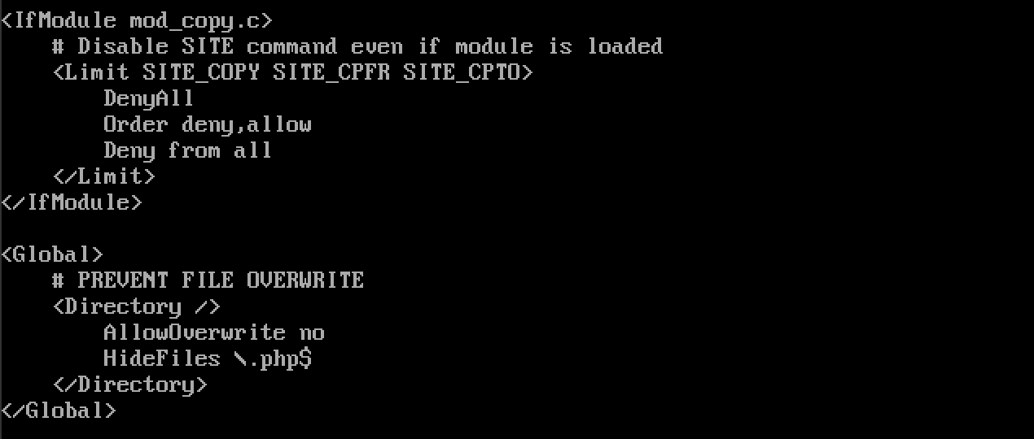
Step 2: We ran the same attack that was performed in phase 1, to test our defence mechanism. The attack failed, which indicates a good defence mechanism as dsplayed in the image below
